

Internet of Things Workshop

Lab 4

Visualizing with Power BI

Change Record

|  |  |  |  |
| --- | --- | --- | --- |
| Date | Author | Version | Change Reference |
| 10/8/2015 | Chmitch | 1.0 | Initial draft |
|  |  |  |  |

Table of Contents

Change Record 2

Introduction 4

Environment setup 4

1.) Build a report with Power BI 5

2.) Pin items to a dashboard with Power BI 8

3.) Explore data with Q&A 11

Introduction

This lab is focused on configuring visualizing streaming data with Power BI which has been delivered to Power BI from Azure Stream Analytics. In this lab we’ll explore the data, build reports and dashboards, and explore the data with some natural language queries. This lab is the fourth in a series that walks through building an end-to-end Internet of Things prototype for doing temperature monitoring.

In this series of labs you will:

1. Assemble an Arduino Uno device for temperature monitoring using a prototype kit, and code and deploy a sketch using the Arduino IDE.
2. Write a gateway application (Universal Windows App) on a Raspberry PI to receive the serial data from the Arduino and send data to an Azure IoT Hub.
3. Configure Azure Stream Analytics jobs for gathering and aggregating streaming data for reporting purposes.
4. Build a Power BI dashboard for visualizing real-time and historical event data from the sensor.
5. Integrate the gateway app with the Azure IoT Suite Remote Monitoring pre-configured solution.

At the end of this lab you will be able to visualize your sensor data via a PowerBI dashboard and demonstrate interactive natural language querying of sensor data

Environment setup

This lab assumes Labs 1 - 3 have already been completed. The requirements from these prior labs should sufficient to complete this lab.

1.) Build a report with Power BI

In this section you will familiarize yourself the report designer experience in Power BI. This designer is a great way to quickly build compelling reports.

1. Navigate to [www.powerbi.com](http://www.powerbi.com) and sign in to your account.
2. In the Power BI window’s “Datasets” section you will see a new dataset appear called “sensorevents”.  
   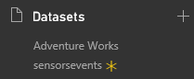  
   Note: if you stared the job and/or your gateway immediately before logging into Power BI it may take a minute for this to show up. To be sure everything is working it’s a good idea to double check your Stream Analytics job to be sure it’s not in a failed state.
3. Click on the “sensordata” item under “Datesets” to connect to the data set for building a report. You will be presented a blank report for development. On the far right is your “Fields” pane for selecting data.  
   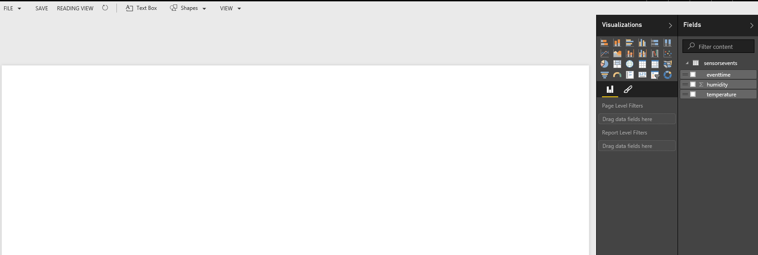
4. The fields pane is used to select the fields you want on the report. It can be done by either drag and drop, or by just clicking a field. For our purposes we want to look at a chart of temperature over time. Click first on the temperature field, then on eventtime. You will be presented a barchart that shows the temperature trend over time.  
   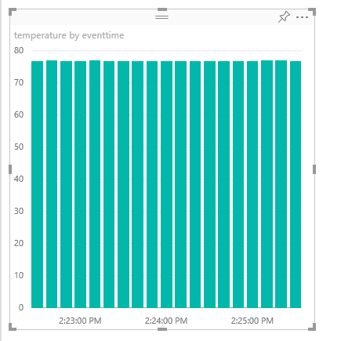
5. For time series data, a line chart does a much better job, in the “Visualizations” pane, click the line chart icon . You’ll now see the data represented as a line chart.  
   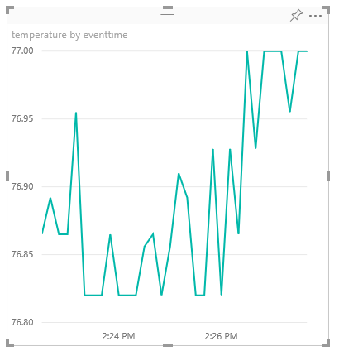
6. You may do the same activity with the humidity data. Furthermore you can adjust the charts layout to suit your purposes.  
   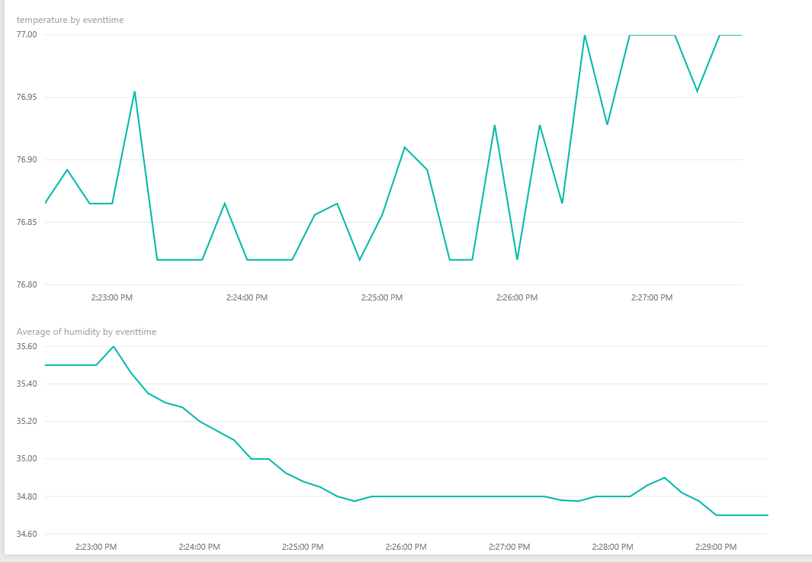
7. Congratulations, you’ve built a report on your streaming data with Power BI. Click “SAVE” and name your report “Sensor Report”.
8. In the left navigation pane you will now see your report under the “Reports” section so you can get back to it as often as you like.  
   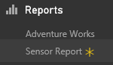

2.) Pin items to a dashboard with Power BI

In this section you will build a basic dashboard with Power BI. Power BI dashboards are good landing pages to get a view of current information:

1. On the “Sensor Report” drag your mouse over a chart. Notice a border appears around the chart.  
   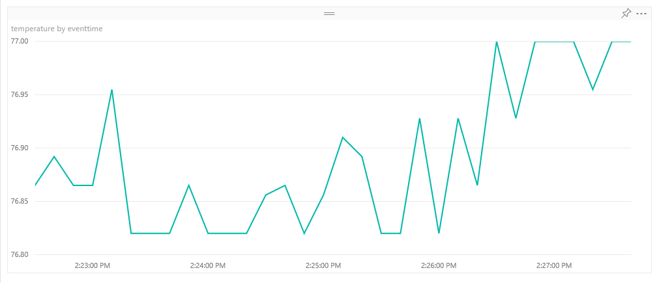
2. Click the pin at the top right corner of the chart.  
   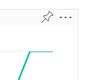
3. You will be displayed a dialogue asking which dashboard you’d like to pin the chart to. Select “New Dashboard”, name the dashboard “Sensor Dashboard”, and click “Pin”.  
   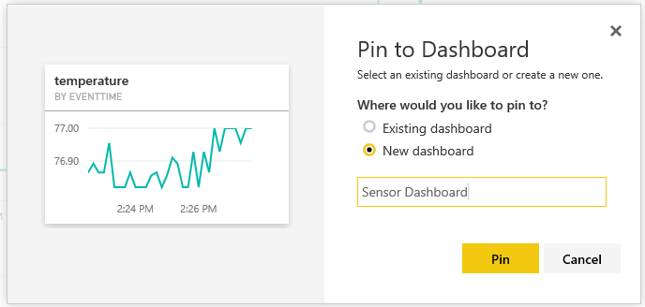
4. Repeat steps 1 – 2 on another chart. This time select “Existing Dashboard” and “Sensor Dashboard” to pin the chart to the same dashboard.  
   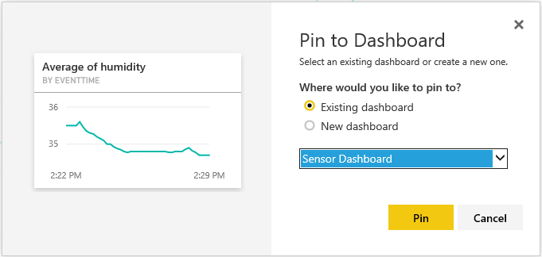
5. On the left hand navigation pane, select “Sensor Dashboard” from the “Dashboards” section.  
   
6. You will be displayed your dashboard. Watch closely, you’ll se that you have been presented moving charts. This happens because your data source is being updated real time, the charts are designed to show a consistent range of data by default.  
   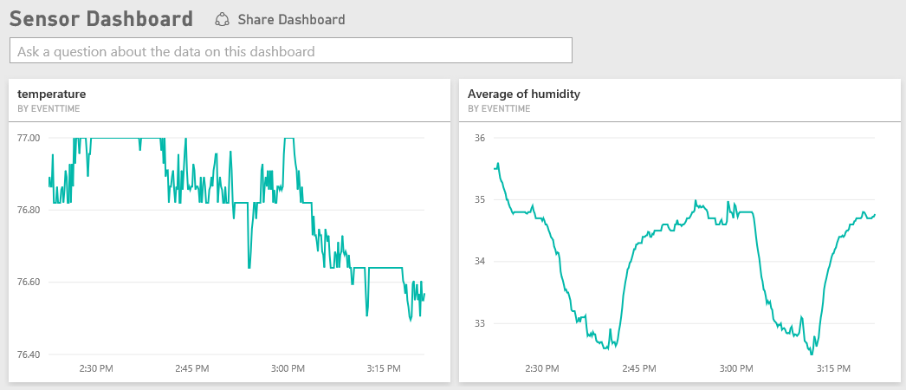
7. On this dashboard you can resize and rearrange the dashboard elements to fit your purposes. For example:  
   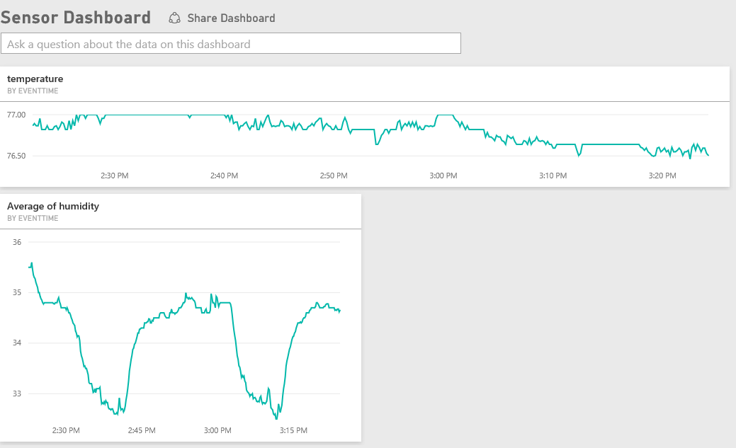
8. Finally, if you’d like to navigate to your source report, simply click on one of the charts. Note that a dashboard can be built of multiple source reports, so each chart on a dashboard could be used to navigate to a different report.

3.) Explore data with Q&A

In this section you will use Power BI’s natural language query tool “Q&A” to explore the data. This is a great option for answering questions about the data in a natural way without having to understand the data.

1. On the top of the Sensor Dashboard there should be box that says “Ask a question about the data on this dashboard”. This box is the Q&A pane. In this box we can ask questions about the data instead of building a report.
2. Type “temperature” in the box. Notice we immediately get an answer:  
   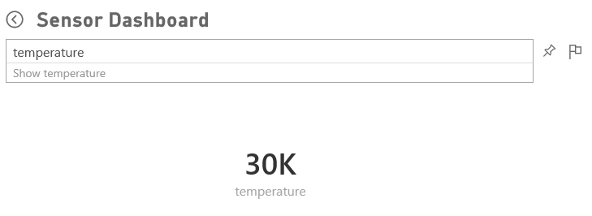
3. This answer isn’t very helpful because it aggregated all the temperatures. Let’s try again, type “average temperature”.  
   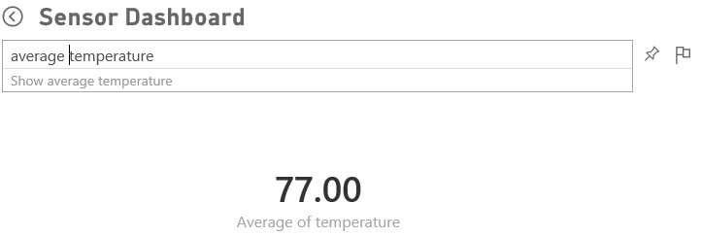
4. This answer is more useful, now let’s change the visualization type “average temperature as bar”.  
   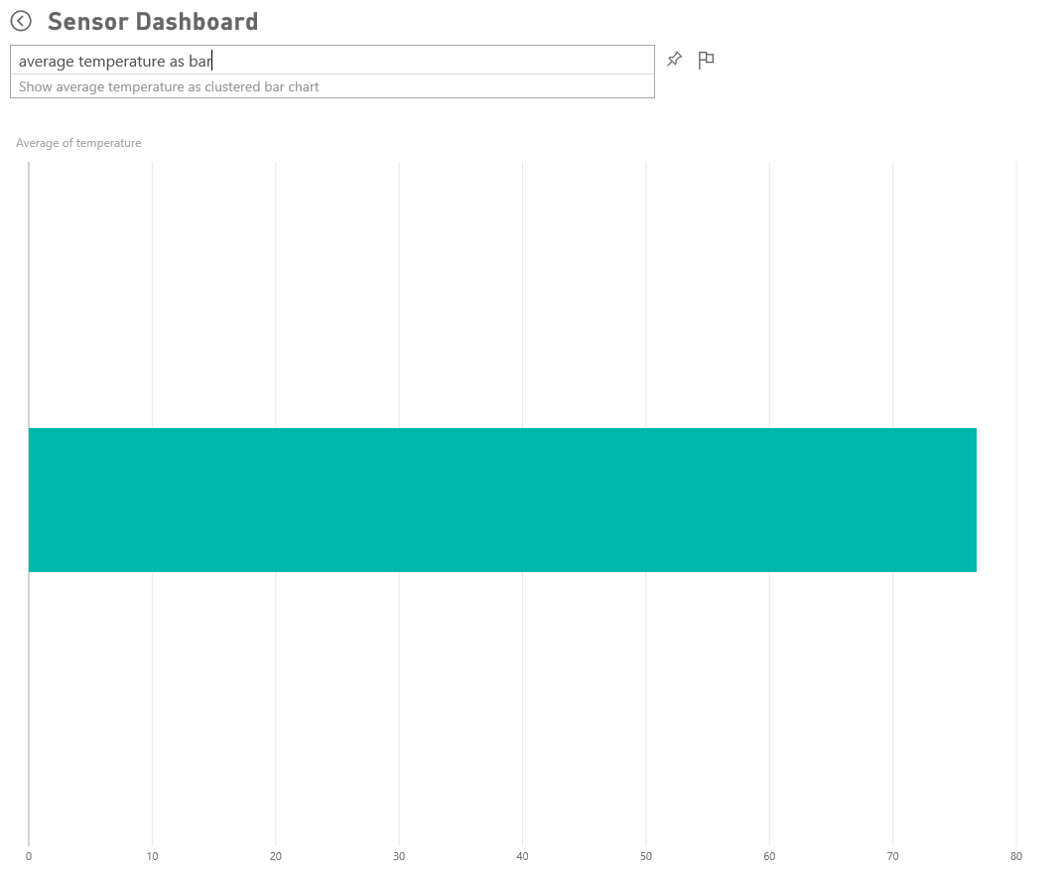
5. Let’s add some more context to the question, type “average temperature by eventtime”  
   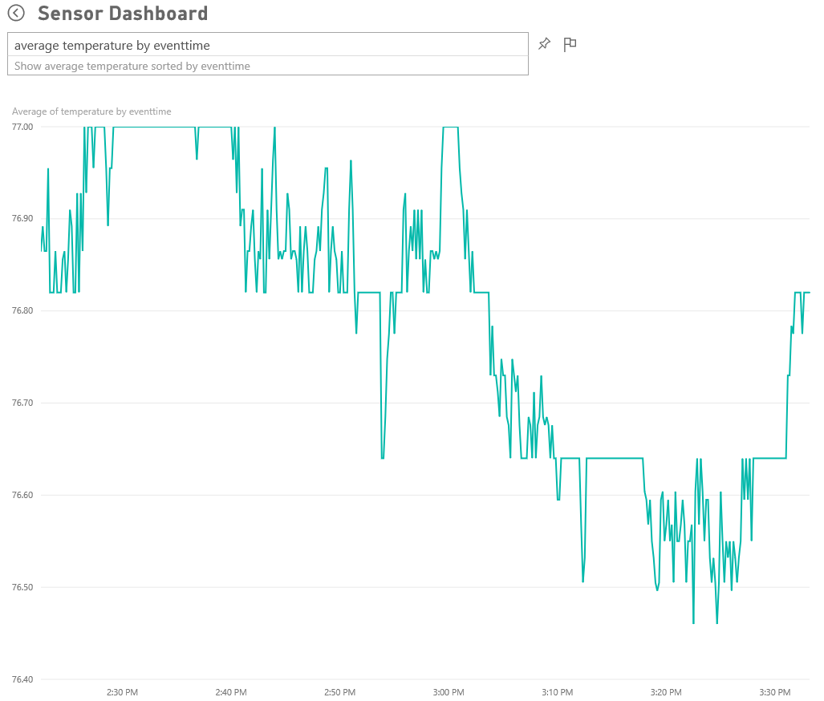
6. To get more precise we can not only add measure and series to the question we can also add filtration criteria. Type “average temperature by event time for last 5 minutes”  
   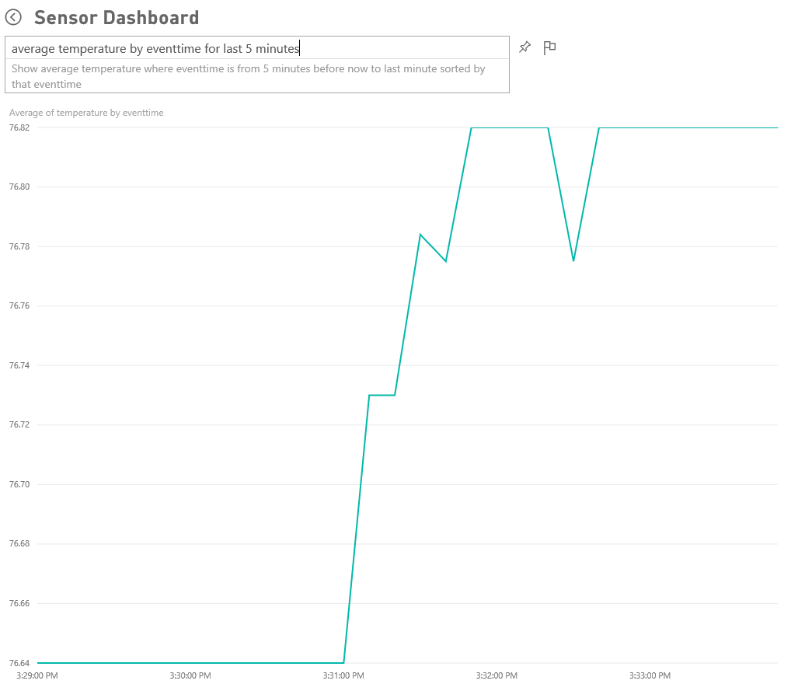
7. Take a closer look at the question pane. Notice we asked a pretty clear question, but Q&A translated it into something the machine could understand.  
   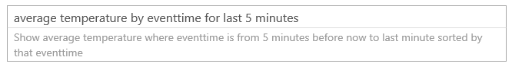
8. Let’s build a simple indicator telling us recent temperature. Type “average temperature for last 30 seconds”.  
   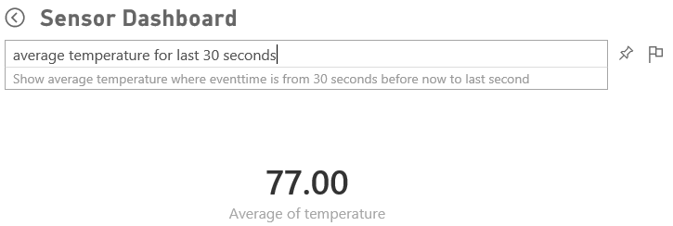
9. Click the pin to pin this visual to your dashboard.  
   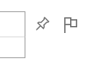
10. In the Pin to Dashboard dialogue select the “Sensor Dashboard” and click Pin.
11. Navigate back to the Sensor dashboard to see the average temperature on the dashboard.  
    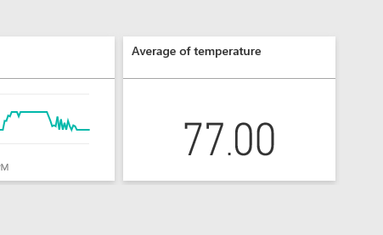
12. Note if you click on the element created with Q&A it will take you into the Q&A view and show the question you asked.
13. Breathe on your sensor for a 5 – 10 seconds to influence the temperature and humidity. Notice that the dashboards update to reflect the activity, and the value ranges on the charts update automatically.  
    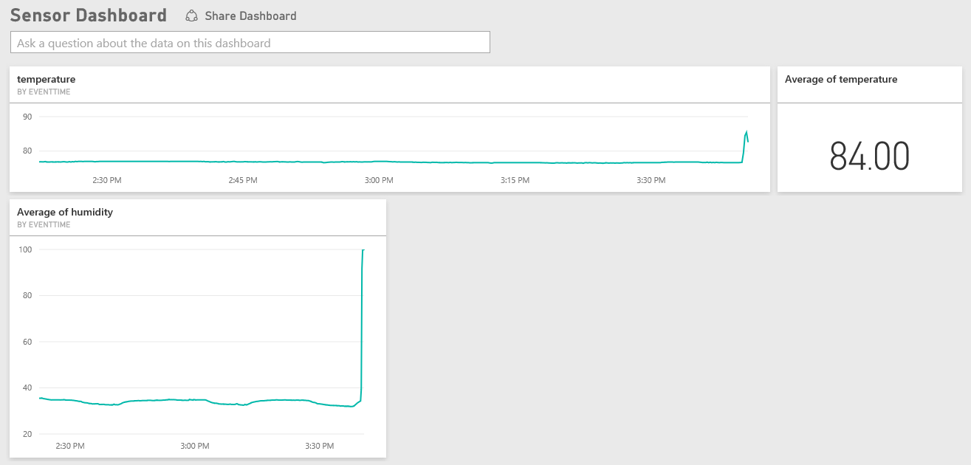
14. Congratulations you’ve used Q&A to add elements to your dashboard.